**Before Lts-**

**Create Curl -**

curl --location 'http://localhost:8087/egov-user-event/v1/events/_create' \

--header 'Content-Type: application/json' \

--data '{

"RequestInfo": {

"apiId": "org.egov.pt",

"ver": "1.0",

"ts": 1502890899493,

"action": "asd",

"did": "4354648646",

"key": "xyz",

"msgId": "654654",

"requesterId": "61",

"authToken": "d9994555-7656-4a67-ab3a-a952a0d4dfc8",

"userInfo": {

"id": 1,

"uuid":"1fec8102-0e02-4d0a-b283-cd80d5dab067",

"type": "EMPLOYEE",

"tenantId": "pg.citya",

"roles": [

{

"name": "Employee",

"code": "EMPLOYEE",

"tenantId": "pg.citya"

}

]

}

},

"events": [

{

"tenantId": "pg.citya",

"eventType": "SYSTEMGENERATED",

"description": "Dear Citizen, Payment for PT assessment with ID: AS-2019-07-17-057018 is Pending. Proceed to Pay",

"name":"PT Pending Payement",

"source": "webapp",

"actions": {

"actionUrls": [

{

"actionUrl": "https://egov-micro-dev.egovernments.org/citizen/otpLogin?mobileNo=9686987977&property-tax/assessment-form?assessmentId=AS-2019-07-17-057018&isReassesment=true&propertyId=PT-107-017534&tenantId=pg.citya&FY=2018-19",

"code": "PAY"

}

]

},

"recepient": {

"toUsers": [

"5417dbb7-14b9-4be2-ac46-ce2decb30444"

]

}

}

]

}'

Response-

{

"events": [

{

"tenantId": "pg.citya",

"id": "babfdda2-f9d7-468c-a568-9ca5d9936dcd",

"referenceId": null,

"eventType": "SYSTEMGENERATED",

"eventCategory": null,

"name": "PT Pending Payement",

"description": "Dear Citizen, Payment for PT assessment with ID: AS-2019-07-17-057018 is Pending. Proceed to Pay",

"status": "ACTIVE",

"source": "WEBAPP",

"postedBy": "1fec8102-0e02-4d0a-b283-cd80d5dab067",

"recepient": {

"toRoles": null,

"toUsers": [

"5417dbb7-14b9-4be2-ac46-ce2decb30444"

]

},

"actions": {

"tenantId": "pg.citya",

"id": "4e75d3d8-c235-440f-b9ab-a508db8f1a4f",

"eventId": "babfdda2-f9d7-468c-a568-9ca5d9936dcd",

"actionUrls": [

{

"actionUrl": "https://egov-micro-dev.egovernments.org/citizen/otpLogin?mobileNo=9686987977&property-tax/assessment-form?assessmentId=AS-2019-07-17-057018&isReassesment=true&propertyId=PT-107-017534&tenantId=pg.citya&FY=2018-19",

"code": "PAY"

}

]

},

"eventDetails": null,

"auditDetails": {

"createdBy": "1fec8102-0e02-4d0a-b283-cd80d5dab067",

"createdTime": 1757331129267,

"lastModifiedBy": "1fec8102-0e02-4d0a-b283-cd80d5dab067",

"lastModifiedTime": 1757331129267

},

"recepientEventMap": null,

"generateCounterEvent": null,

"internallyUpdted": null

}

],

"ResponseInfo": {

"apiId": "org.egov.pt",

"ver": "1.0",

"ts": 1502890899493,

"resMsgId": "uief87324",

"msgId": "654654",

"status": "successful"

}

}

**Search Curl -**

curl --location 'http://localhost:8087/egov-user-event/v1/events/_search?tenantId=pg.citya&name=PT%20Pending%20Payement' \

--header 'Content-Type: application/json' \

--data '{

"RequestInfo": {

"apiId": "org.egov.pt",

"ver": "1.0",

"ts": 1502890899493,

"action": "_search",

"did": "4354648646",

"key": "xyz",

"msgId": "654654",

"requesterId": "61",

"authToken": "d9994555-7656-4a67-ab3a-a952a0d4dfc8",

"userInfo": {

"id": 1,

"uuid": "1fec8102-0e02-4d0a-b283-cd80d5dab067",

"type": "EMPLOYEE",

"tenantId": "pg.citya",

"roles": [

{

"name": "Employee",

"code": "EMPLOYEE",

"tenantId": "pg.citya"

}

]

}

}

}'

**Response-**

{

"events": [

{

"tenantId": "pg.citya",

"id": "0a5643da-b5b1-4cb4-8d5c-3dfaf74ee0aa",

"referenceId": null,

"eventType": "SYSTEMGENERATED",

"eventCategory": null,

"name": "PT Pending Payement",

"description": "Dear Citizen, Payment for PT assessment with ID: AS-2019-07-17-057018 is Pending. Proceed to Pay",

"status": "ACTIVE",

"source": "WEBAPP",

"postedBy": "1fec8102-0e02-4d0a-b283-cd80d5dab067",

"recepient": {

"toRoles": null,

"toUsers": [

"5417dbb7-14b9-4be2-ac46-ce2decb30444"

]

},

"actions": {

"tenantId": "pg.citya",

"id": "6122f131-620e-4e46-a6d0-629929093f6d",

"eventId": "0a5643da-b5b1-4cb4-8d5c-3dfaf74ee0aa",

"actionUrls": [

{

"actionUrl": "https://egov-micro-dev.egovernments.org/citizen/otpLogin?mobileNo=9686987977&property-tax/assessment-form?assessmentId=AS-2019-07-17-057018&isReassesment=true&propertyId=PT-107-017534&tenantId=pg.citya&FY=2018-19",

"code": "PAY"

}

]

},

"eventDetails": null,

"auditDetails": {

"createdBy": "1fec8102-0e02-4d0a-b283-cd80d5dab067",

"createdTime": 1757333919582,

"lastModifiedBy": "1fec8102-0e02-4d0a-b283-cd80d5dab067",

"lastModifiedTime": 1757333919582

},

"recepientEventMap": null,

"generateCounterEvent": null,

"internallyUpdted": null

},

{

"tenantId": "pg.citya",

"id": "f6f1f044-1938-42d3-84bf-e00a3ac443ce",

"referenceId": null,

"eventType": "SYSTEMGENERATED",

"eventCategory": null,

"name": "PT Pending Payement",

"description": "Dear Citizen, Payment for PT assessment with ID: AS-2019-07-17-057018 is Pending. Proceed to Pay",

"status": "ACTIVE",

"source": "WEBAPP",

"postedBy": "1fec8102-0e02-4d0a-b283-cd80d5dab067",

"recepient": {

"toRoles": null,

"toUsers": [

"5417dbb7-14b9-4be2-ac46-ce2decb30444"

]

},

"actions": {

"tenantId": "pg.citya",

"id": "55741467-c6a9-4475-ba6e-415ef581ee92",

"eventId": "f6f1f044-1938-42d3-84bf-e00a3ac443ce",

"actionUrls": [

{

"actionUrl": "https://egov-micro-dev.egovernments.org/citizen/otpLogin?mobileNo=9686987977&property-tax/assessment-form?assessmentId=AS-2019-07-17-057018&isReassesment=true&propertyId=PT-107-017534&tenantId=pg.citya&FY=2018-19",

"code": "PAY"

}

]

},

"eventDetails": null,

"auditDetails": {

"createdBy": "1fec8102-0e02-4d0a-b283-cd80d5dab067",

"createdTime": 1757333734829,

"lastModifiedBy": "1fec8102-0e02-4d0a-b283-cd80d5dab067",

"lastModifiedTime": 1757333734829

},

"recepientEventMap": null,

"generateCounterEvent": null,

"internallyUpdted": null

},

{

"tenantId": "pg.citya",

"id": "babfdda2-f9d7-468c-a568-9ca5d9936dcd",

"referenceId": null,

"eventType": "SYSTEMGENERATED",

"eventCategory": null,

"name": "PT Pending Payement",

"description": "Dear Citizen, Payment for PT assessment with ID: AS-2019-07-17-057018 is Pending. Proceed to Pay",

"status": "ACTIVE",

"source": "WEBAPP",

"postedBy": "1fec8102-0e02-4d0a-b283-cd80d5dab067",

"recepient": {

"toRoles": null,

"toUsers": [

"5417dbb7-14b9-4be2-ac46-ce2decb30444"

]

},

"actions": {

"tenantId": "pg.citya",

"id": "4e75d3d8-c235-440f-b9ab-a508db8f1a4f",

"eventId": "babfdda2-f9d7-468c-a568-9ca5d9936dcd",

"actionUrls": [

{

"actionUrl": "https://egov-micro-dev.egovernments.org/citizen/otpLogin?mobileNo=9686987977&property-tax/assessment-form?assessmentId=AS-2019-07-17-057018&isReassesment=true&propertyId=PT-107-017534&tenantId=pg.citya&FY=2018-19",

"code": "PAY"

}

]

},

"eventDetails": null,

"auditDetails": {

"createdBy": "1fec8102-0e02-4d0a-b283-cd80d5dab067",

"createdTime": 1757331129267,

"lastModifiedBy": "1fec8102-0e02-4d0a-b283-cd80d5dab067",

"lastModifiedTime": 1757331129267

},

"recepientEventMap": null,

"generateCounterEvent": null,

"internallyUpdted": null

},

{

"tenantId": "pg.citya",

"id": "f6749b66-a7cb-4754-9576-4c2cf6ffb3c9",

"referenceId": null,

"eventType": "SYSTEMGENERATED",

"eventCategory": null,

"name": "PT Pending Payement",

"description": "Dear Citizen, Payment for PT assessment with ID: AS-2019-07-17-057018 is Pending. Proceed to Pay",

"status": "ACTIVE",

"source": "WEBAPP",

"postedBy": "1fec8102-0e02-4d0a-b283-cd80d5dab067",

"recepient": {

"toRoles": null,

"toUsers": [

"5417dbb7-14b9-4be2-ac46-ce2decb30444"

]

},

"actions": {

"tenantId": "pg.citya",

"id": "4f13f9b6-401d-41e8-80a0-40f4a3b5c7f3",

"eventId": "f6749b66-a7cb-4754-9576-4c2cf6ffb3c9",

"actionUrls": [

{

"actionUrl": "https://egov-micro-dev.egovernments.org/citizen/otpLogin?mobileNo=9686987977&property-tax/assessment-form?assessmentId=AS-2019-07-17-057018&isReassesment=true&propertyId=PT-107-017534&tenantId=pg.citya&FY=2018-19",

"code": "PAY"

}

]

},

"eventDetails": null,

"auditDetails": {

"createdBy": "1fec8102-0e02-4d0a-b283-cd80d5dab067",

"createdTime": 1757329890355,

"lastModifiedBy": "1fec8102-0e02-4d0a-b283-cd80d5dab067",

"lastModifiedTime": 1757329890355

},

"recepientEventMap": null,

"generateCounterEvent": null,

"internallyUpdted": null

}

],

"ResponseInfo": {

"apiId": "org.egov.pt",

"ver": "1.0",

"ts": 1502890899493,

"resMsgId": "uief87324",

"msgId": "654654",

"status": "successful"

},

"totalCount": 4

}

**Count Curl -**

curl --location 'http://localhost:8087/egov-user-event/v1/events/notifications/_count?tenantId=pg.citya' \

--header 'Content-Type: application/json' \

--data '{

"RequestInfo": {

"apiId": "org.egov.pt",

"ver": "1.0",

"ts": 1502890899493,

"action": "asd",

"did": "4354648646",

"key": "xyz",

"msgId": "654654",

"requesterId": "61",

"authToken": "0590b6f3-4906-4d24-a862-ec06070203b1",

"userInfo": {

"id": 1,

"uuid":"5417dbb7-14b9-4be2-ac46-ce2decb30444",

"type": "CITIZEN",

"tenantId": "pg.citya",

"roles": [

{

"name": "Citizen",

"code": "CITIZEN",

"tenantId": "pg.citya"

}

]

}

}

}'

**Response -**

{

"totalCount": 5,

"unreadCount": 5,

"ResponseInfo": {

"apiId": "org.egov.pt",

"ver": "1.0",

"ts": 1502890899493,

"resMsgId": "uief87324",

"msgId": "654654",

"status": "successful"

}

}

**LAT (Last Access Time) - update Curl**

* Before /lat/_update: Notifications created before the user's last access time were "unread"
* After /lat/_update: The user's last access time was updated to current timestamp
* Now all existing notifications are considered "read" since they were created before the updated last access time

Curl -

curl --location 'http://localhost:8087/egov-user-event/v1/events/lat/_update' \

--header 'Content-Type: application/json' \

--data '{

"RequestInfo": {

"apiId": "org.egov.pt",

"ver": "1.0",

"ts": 1502890899493,

"action": "asd",

"did": "4354648646",

"key": "xyz",

"msgId": "654654",

"requesterId": "61",

"authToken": "685176f7-45dd-40b3-8821-93912a6d3dc0",

"userInfo": {

"id": 1,

"uuid":"5417dbb7-14b9-4be2-ac46-ce2decb30444",

"type": "CITIZEN",

"tenantId": "pg.citya",

"roles": [

{

"name": "Citizen",

"code": "CITIZEN",

"tenantId": "pg.citya"

}

]

}

}

}'

Response -

{

"apiId": "org.egov.pt",

"ver": "1.0",

"ts": 1502890899493,

"resMsgId": "uief87324",

"msgId": "654654",

"status": "successful"

}

**Update curl -**

curl --location 'http://localhost:8087/egov-user-event/v1/events/_update' \

--header 'Content-Type: application/json' \

--data '{

"RequestInfo": {

"apiId": "org.egov.pt",

"ver": "1.0",

"ts": 1502890899493,

"action": "asd",

"did": "4354648646",

"key": "xyz",

"msgId": "654654",

"requesterId": "61",

"authToken": "d1ddc056-d5bb-4c65-ad49-c3c04595fc31",

"userInfo": {

"id": 1,

"uuid": "1fec8102-0e02-4d0a-b283-cd80d5dab067",

"type": "EMPLOYEE",

"tenantId": "pg.citya",

"roles": [

{

"name": "Employee",

"code": "EMPLOYEE",

"tenantId": "pg.citya"

}

]

}

},

"events": [

{

"tenantId": "pg.citya",

"id": "335b84c0-5288-4476-8b9b-618ae411c322",

"eventType": "EVENTSONGROUND",

"eventCategory": "PUBLICHEALTH",

"name": "Run for the Environment - UPDATED",

"description": "The ULB has organised a Marathon for environmental awareness, Please participate - UPDATED DESCRIPTION.",

"status": "ACTIVE",

"source": "WEBAPP",

"eventDetails": {

"organizer": "Soorya P - Updated",

"fromDate": 1767225600000,

"toDate": 1767312000000,

"latitude": 11.11,

"longitude": 11.11,

"address": "Updated Address - Mcleod Road, Rani Ka Bagh, Amritsar",

"fees": 1500

},

"auditDetails": {

"createdBy": "1fec8102-0e02-4d0a-b283-cd80d5dab067",

"createdTime": 1565079560614,

"lastModifiedBy": "1fec8102-0e02-4d0a-b283-cd80d5dab067",

"lastModifiedTime": 1757333919582

}

}

]

}'

**Response -**

{

"events": [

{

"tenantId": "pg.citya",

"id": "335b84c0-5288-4476-8b9b-618ae411c322",

"referenceId": null,

"eventType": "EVENTSONGROUND",

"eventCategory": "PUBLICHEALTH",

"name": "Run for the Environment - UPDATED",

"description": "The ULB has organised a Marathon for environmental awareness, Please participate - UPDATED DESCRIPTION.",

"status": "ACTIVE",

"source": "WEBAPP",

"postedBy": null,

"recepient": null,

"actions": null,

"eventDetails": {

"id": "1b2b6177-a15b-4e60-b016-6b97f92e7780",

"eventId": "59da607b-d680-47cd-acb2-3051b0bb1a62",

"organizer": "Soorya P - Updated",

"fromDate": 1767225600000,

"toDate": 1767312000000,

"latitude": 11.11,

"longitude": 11.11,

"address": "Updated Address - Mcleod Road, Rani Ka Bagh, Amritsar",

"documents": null,

"fees": 1500

},

"auditDetails": {

"createdBy": "1fec8102-0e02-4d0a-b283-cd80d5dab067",

"createdTime": 1565079560614,

"lastModifiedBy": "1fec8102-0e02-4d0a-b283-cd80d5dab067",

"lastModifiedTime": 1757400063180

},

"recepientEventMap": null,

"generateCounterEvent": null,

"internallyUpdted": null

}

],

"ResponseInfo": {

"apiId": "org.egov.pt",

"ver": "1.0",

"ts": 1502890899493,

"resMsgId": "uief87324",

"msgId": "654654",

"status": "successful"

}

}

**After Lts-**

**Create curl -**

curl --location 'http://localhost:8087/egov-user-event/v1/events/_create' \

--header 'Content-Type: application/json' \

--header 'Cookie: JSESSIONID=64B00DE3C5A51A09ACAF5A7142EFECDE' \

--data '{

"RequestInfo": {

"apiId": "org.egov.pt",

"ver": "1.0",

"ts": 1502890899493,

"action": "asd",

"did": "4354648646",

"key": "xyz",

"msgId": "654654",

"requesterId": "61",

"authToken": "d9994555-7656-4a67-ab3a-a952a0d4dfc8",

"userInfo": {

"id": 1,

"uuid":"1fec8102-0e02-4d0a-b283-cd80d5dab067",

"type": "EMPLOYEE",

"tenantId": "pg.citya",

"roles": [

{

"name": "Employee",

"code": "EMPLOYEE",

"tenantId": "pg.citya"

}

]

}

},

"events": [

{

"tenantId": "pg.citya",

"eventType": "SYSTEMGENERATED",

"description": "Dear Citizen, Creating Event After Lts Upgrade",

"name":"PT Pending Payement",

"source": "webapp",

"actions": {

"actionUrls": [

{

"actionUrl": "https://egov-micro-dev.egovernments.org/citizen/otpLogin?mobileNo=9686987977&property-tax/assessment-form?assessmentId=AS-2019-07-17-057018&isReassesment=true&propertyId=PT-107-017534&tenantId=pg.citya&FY=2018-19",

"code": "PAY"

}

]

},

"recepient": {

"toUsers": [

"5417dbb7-14b9-4be2-ac46-ce2decb30444"

]

}

}

]

}'

**Response-**

{

"events": [

{

"tenantId": "pg.citya",

"id": "052741ef-fd24-48d6-b2e8-e7b0584520b3",

"referenceId": null,

"eventType": "SYSTEMGENERATED",

"eventCategory": null,

"name": "PT Pending Payement",

"description": "Dear Citizen, Creating Event After Lts Upgrade",

"status": "ACTIVE",

"source": "WEBAPP",

"postedBy": "1fec8102-0e02-4d0a-b283-cd80d5dab067",

"recepient": {

"toRoles": null,

"toUsers": [

"5417dbb7-14b9-4be2-ac46-ce2decb30444"

]

},

"actions": {

"tenantId": "pg.citya",

"id": "710cf848-a77d-4de4-97ab-024ef146a6ab",

"eventId": "052741ef-fd24-48d6-b2e8-e7b0584520b3",

"actionUrls": [

{

"actionUrl": "https://egov-micro-dev.egovernments.org/citizen/otpLogin?mobileNo=9686987977&property-tax/assessment-form?assessmentId=AS-2019-07-17-057018&isReassesment=true&propertyId=PT-107-017534&tenantId=pg.citya&FY=2018-19",

"code": "PAY"

}

]

},

"eventDetails": null,

"auditDetails": {

"createdBy": "1fec8102-0e02-4d0a-b283-cd80d5dab067",

"createdTime": 1757486478585,

"lastModifiedBy": "1fec8102-0e02-4d0a-b283-cd80d5dab067",

"lastModifiedTime": 1757486478585

},

"recepientEventMap": null,

"generateCounterEvent": null,

"internallyUpdted": null

}

],

"ResponseInfo": {

"apiId": "org.egov.pt",

"ver": "1.0",

"ts": 1502890899493,

"resMsgId": "uief87324",

"msgId": "654654",

"status": "successful"

}

}

Postman -

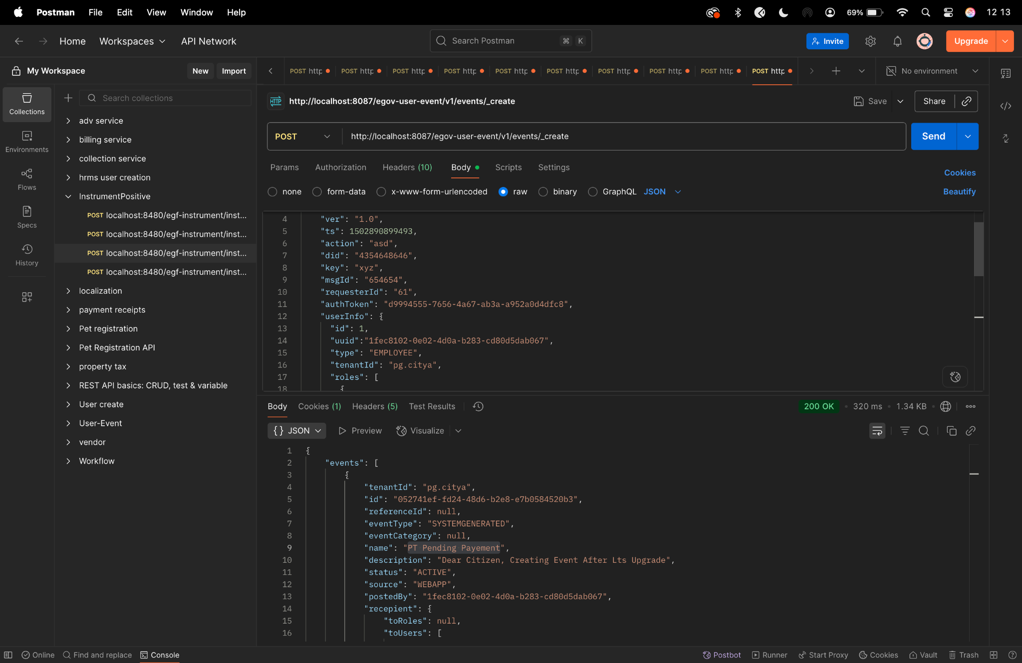

Diff checker-

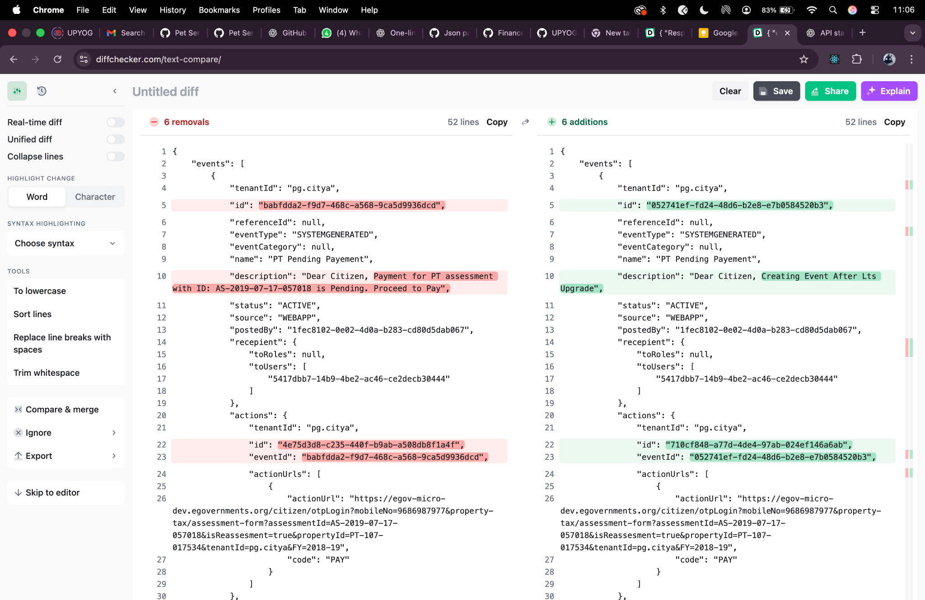

**Search curl-**

curl --location 'http://localhost:8087/egov-user-event/v1/events/_search?tenantId=pg.citya&name=PT%20Pending%20Payement' \

--header 'Content-Type: application/json' \

--header 'Cookie: JSESSIONID=64B00DE3C5A51A09ACAF5A7142EFECDE' \

--data '{

"RequestInfo": {

"apiId": "org.egov.pt",

"ver": "1.0",

"ts": 1502890899493,

"action": "_search",

"did": "4354648646",

"key": "xyz",

"msgId": "654654",

"requesterId": "61",

"authToken": "d9994555-7656-4a67-ab3a-a952a0d4dfc8",

"userInfo": {

"id": 1,

"uuid": "1fec8102-0e02-4d0a-b283-cd80d5dab067",

"type": "EMPLOYEE",

"tenantId": "pg.citya",

"roles": [

{

"name": "Employee",

"code": "EMPLOYEE",

"tenantId": "pg.citya"

}

]

}

}

}'

**Response-**

{

"events": [

{

"tenantId": "pg.citya",

"id": "052741ef-fd24-48d6-b2e8-e7b0584520b3",

"referenceId": null,

"eventType": "SYSTEMGENERATED",

"eventCategory": null,

"name": "PT Pending Payement",

"description": "Dear Citizen, Creating Event After Lts Upgrade",

"status": "ACTIVE",

"source": "WEBAPP",

"postedBy": "1fec8102-0e02-4d0a-b283-cd80d5dab067",

"recepient": {

"toRoles": null,

"toUsers": [

"5417dbb7-14b9-4be2-ac46-ce2decb30444"

]

},

"actions": {

"tenantId": "pg.citya",

"id": "710cf848-a77d-4de4-97ab-024ef146a6ab",

"eventId": "052741ef-fd24-48d6-b2e8-e7b0584520b3",

"actionUrls": [

{

"actionUrl": "https://egov-micro-dev.egovernments.org/citizen/otpLogin?mobileNo=9686987977&property-tax/assessment-form?assessmentId=AS-2019-07-17-057018&isReassesment=true&propertyId=PT-107-017534&tenantId=pg.citya&FY=2018-19",

"code": "PAY"

}

]

},

"eventDetails": null,

"auditDetails": {

"createdBy": "1fec8102-0e02-4d0a-b283-cd80d5dab067",

"createdTime": 1757486478585,

"lastModifiedBy": "1fec8102-0e02-4d0a-b283-cd80d5dab067",

"lastModifiedTime": 1757486478585

},

"recepientEventMap": null,

"generateCounterEvent": null,

"internallyUpdted": null

},

{

"tenantId": "pg.citya",

"id": "018a9dec-a533-4b57-b2e2-087a7a8500e0",

"referenceId": null,

"eventType": "SYSTEMGENERATED",

"eventCategory": null,

"name": "PT Pending Payement",

"description": "Dear Citizen, This notification is sent for the testing purpose - FOR THE UPDATE CURL ",

"status": "ACTIVE",

"source": "WEBAPP",

"postedBy": "1fec8102-0e02-4d0a-b283-cd80d5dab067",

"recepient": {

"toRoles": null,

"toUsers": [

"5417dbb7-14b9-4be2-ac46-ce2decb30444"

]

},

"actions": {

"tenantId": "pg.citya",

"id": "2bc6c2d1-3369-42a9-972b-892b6cb27e99",

"eventId": "018a9dec-a533-4b57-b2e2-087a7a8500e0",

"actionUrls": [

{

"actionUrl": "https://egov-micro-dev.egovernments.org/citizen/otpLogin?mobileNo=9686987977&property-tax/assessment-form?assessmentId=AS-2019-07-17-057018&isReassesment=true&propertyId=PT-107-017534&tenantId=pg.citya&FY=2018-19",

"code": "PAY"

}

]

},

"eventDetails": null,

"auditDetails": {

"createdBy": "1fec8102-0e02-4d0a-b283-cd80d5dab067",

"createdTime": 1757400247075,

"lastModifiedBy": "1fec8102-0e02-4d0a-b283-cd80d5dab067",

"lastModifiedTime": 1757400247075

},

"recepientEventMap": null,

"generateCounterEvent": null,

"internallyUpdted": null

},

{

"tenantId": "pg.citya",

"id": "ae1bcb95-76a9-45b1-85c4-70163187db3d",

"referenceId": null,

"eventType": "SYSTEMGENERATED",

"eventCategory": null,

"name": "PT Pending Payement",

"description": "Dear Citizen, Payment for PT assessment with ID: AS-2019-07-17-057018 is Pending. Proceed to Pay",

"status": "ACTIVE",

"source": "WEBAPP",

"postedBy": "1fec8102-0e02-4d0a-b283-cd80d5dab067",

"recepient": {

"toRoles": null,

"toUsers": [

"5417dbb7-14b9-4be2-ac46-ce2decb30444"

]

},

"actions": {

"tenantId": "pg.citya",

"id": "057a60ae-90a2-402e-a440-84696e4b7951",

"eventId": "ae1bcb95-76a9-45b1-85c4-70163187db3d",

"actionUrls": [

{

"actionUrl": "https://egov-micro-dev.egovernments.org/citizen/otpLogin?mobileNo=9686987977&property-tax/assessment-form?assessmentId=AS-2019-07-17-057018&isReassesment=true&propertyId=PT-107-017534&tenantId=pg.citya&FY=2018-19",

"code": "PAY"

}

]

},

"eventDetails": null,

"auditDetails": {

"createdBy": "1fec8102-0e02-4d0a-b283-cd80d5dab067",

"createdTime": 1757399087709,

"lastModifiedBy": "1fec8102-0e02-4d0a-b283-cd80d5dab067",

"lastModifiedTime": 1757399087709

},

"recepientEventMap": null,

"generateCounterEvent": null,

"internallyUpdted": null

},

{

"tenantId": "pg.citya",

"id": "4a00806b-b8cc-4572-a6ab-81a1e992d768",

"referenceId": null,

"eventType": "SYSTEMGENERATED",

"eventCategory": null,

"name": "PT Pending Payement",

"description": "Dear Citizen, Payment for PT assessment with ID: AS-2019-07-17-057018 is Pending. Proceed to Pay",

"status": "ACTIVE",

"source": "WEBAPP",

"postedBy": "1fec8102-0e02-4d0a-b283-cd80d5dab067",

"recepient": {

"toRoles": null,

"toUsers": [

"5417dbb7-14b9-4be2-ac46-ce2decb30444"

]

},

"actions": {

"tenantId": "pg.citya",

"id": "62f39cd2-2354-47a1-b5b5-b24f96039d90",

"eventId": "4a00806b-b8cc-4572-a6ab-81a1e992d768",

"actionUrls": [

{

"actionUrl": "https://egov-micro-dev.egovernments.org/citizen/otpLogin?mobileNo=9686987977&property-tax/assessment-form?assessmentId=AS-2019-07-17-057018&isReassesment=true&propertyId=PT-107-017534&tenantId=pg.citya&FY=2018-19",

"code": "PAY"

}

]

},

"eventDetails": null,

"auditDetails": {

"createdBy": "1fec8102-0e02-4d0a-b283-cd80d5dab067",

"createdTime": 1757398130490,

"lastModifiedBy": "1fec8102-0e02-4d0a-b283-cd80d5dab067",

"lastModifiedTime": 1757398130490

},

"recepientEventMap": null,

"generateCounterEvent": null,

"internallyUpdted": null

},

{

"tenantId": "pg.citya",

"id": "0a5643da-b5b1-4cb4-8d5c-3dfaf74ee0aa",

"referenceId": null,

"eventType": "SYSTEMGENERATED",

"eventCategory": null,

"name": "PT Pending Payement",

"description": "Dear Citizen, Payment for PT assessment with ID: AS-2019-07-17-057018 is Pending. Proceed to Pay",

"status": "ACTIVE",

"source": "WEBAPP",

"postedBy": "1fec8102-0e02-4d0a-b283-cd80d5dab067",

"recepient": {

"toRoles": null,

"toUsers": [

"5417dbb7-14b9-4be2-ac46-ce2decb30444"

]

},

"actions": {

"tenantId": "pg.citya",

"id": "6122f131-620e-4e46-a6d0-629929093f6d",

"eventId": "0a5643da-b5b1-4cb4-8d5c-3dfaf74ee0aa",

"actionUrls": [

{

"actionUrl": "https://egov-micro-dev.egovernments.org/citizen/otpLogin?mobileNo=9686987977&property-tax/assessment-form?assessmentId=AS-2019-07-17-057018&isReassesment=true&propertyId=PT-107-017534&tenantId=pg.citya&FY=2018-19",

"code": "PAY"

}

]

},

"eventDetails": null,

"auditDetails": {

"createdBy": "1fec8102-0e02-4d0a-b283-cd80d5dab067",

"createdTime": 1757333919582,

"lastModifiedBy": "1fec8102-0e02-4d0a-b283-cd80d5dab067",

"lastModifiedTime": 1757333919582

},

"recepientEventMap": null,

"generateCounterEvent": null,

"internallyUpdted": null

},

{

"tenantId": "pg.citya",

"id": "f6f1f044-1938-42d3-84bf-e00a3ac443ce",

"referenceId": null,

"eventType": "SYSTEMGENERATED",

"eventCategory": null,

"name": "PT Pending Payement",

"description": "Dear Citizen, Payment for PT assessment with ID: AS-2019-07-17-057018 is Pending. Proceed to Pay",

"status": "ACTIVE",

"source": "WEBAPP",

"postedBy": "1fec8102-0e02-4d0a-b283-cd80d5dab067",

"recepient": {

"toRoles": null,

"toUsers": [

"5417dbb7-14b9-4be2-ac46-ce2decb30444"

]

},

"actions": {

"tenantId": "pg.citya",

"id": "55741467-c6a9-4475-ba6e-415ef581ee92",

"eventId": "f6f1f044-1938-42d3-84bf-e00a3ac443ce",

"actionUrls": [

{

"actionUrl": "https://egov-micro-dev.egovernments.org/citizen/otpLogin?mobileNo=9686987977&property-tax/assessment-form?assessmentId=AS-2019-07-17-057018&isReassesment=true&propertyId=PT-107-017534&tenantId=pg.citya&FY=2018-19",

"code": "PAY"

}

]

},

"eventDetails": null,

"auditDetails": {

"createdBy": "1fec8102-0e02-4d0a-b283-cd80d5dab067",

"createdTime": 1757333734829,

"lastModifiedBy": "1fec8102-0e02-4d0a-b283-cd80d5dab067",

"lastModifiedTime": 1757333734829

},

"recepientEventMap": null,

"generateCounterEvent": null,

"internallyUpdted": null

},

{

"tenantId": "pg.citya",

"id": "babfdda2-f9d7-468c-a568-9ca5d9936dcd",

"referenceId": null,

"eventType": "SYSTEMGENERATED",

"eventCategory": null,

"name": "PT Pending Payement",

"description": "Dear Citizen, Payment for PT assessment with ID: AS-2019-07-17-057018 is Pending. Proceed to Pay",

"status": "ACTIVE",

"source": "WEBAPP",

"postedBy": "1fec8102-0e02-4d0a-b283-cd80d5dab067",

"recepient": {

"toRoles": null,

"toUsers": [

"5417dbb7-14b9-4be2-ac46-ce2decb30444"

]

},

"actions": {

"tenantId": "pg.citya",

"id": "4e75d3d8-c235-440f-b9ab-a508db8f1a4f",

"eventId": "babfdda2-f9d7-468c-a568-9ca5d9936dcd",

"actionUrls": [

{

"actionUrl": "https://egov-micro-dev.egovernments.org/citizen/otpLogin?mobileNo=9686987977&property-tax/assessment-form?assessmentId=AS-2019-07-17-057018&isReassesment=true&propertyId=PT-107-017534&tenantId=pg.citya&FY=2018-19",

"code": "PAY"

}

]

},

"eventDetails": null,

"auditDetails": {

"createdBy": "1fec8102-0e02-4d0a-b283-cd80d5dab067",

"createdTime": 1757331129267,

"lastModifiedBy": "1fec8102-0e02-4d0a-b283-cd80d5dab067",

"lastModifiedTime": 1757331129267

},

"recepientEventMap": null,

"generateCounterEvent": null,

"internallyUpdted": null

},

{

"tenantId": "pg.citya",

"id": "f6749b66-a7cb-4754-9576-4c2cf6ffb3c9",

"referenceId": null,

"eventType": "SYSTEMGENERATED",

"eventCategory": null,

"name": "PT Pending Payement",

"description": "Dear Citizen, Payment for PT assessment with ID: AS-2019-07-17-057018 is Pending. Proceed to Pay",

"status": "ACTIVE",

"source": "WEBAPP",

"postedBy": "1fec8102-0e02-4d0a-b283-cd80d5dab067",

"recepient": {

"toRoles": null,

"toUsers": [

"5417dbb7-14b9-4be2-ac46-ce2decb30444"

]

},

"actions": {

"tenantId": "pg.citya",

"id": "4f13f9b6-401d-41e8-80a0-40f4a3b5c7f3",

"eventId": "f6749b66-a7cb-4754-9576-4c2cf6ffb3c9",

"actionUrls": [

{

"actionUrl": "https://egov-micro-dev.egovernments.org/citizen/otpLogin?mobileNo=9686987977&property-tax/assessment-form?assessmentId=AS-2019-07-17-057018&isReassesment=true&propertyId=PT-107-017534&tenantId=pg.citya&FY=2018-19",

"code": "PAY"

}

]

},

"eventDetails": null,

"auditDetails": {

"createdBy": "1fec8102-0e02-4d0a-b283-cd80d5dab067",

"createdTime": 1757329890355,

"lastModifiedBy": "1fec8102-0e02-4d0a-b283-cd80d5dab067",

"lastModifiedTime": 1757329890355

},

"recepientEventMap": null,

"generateCounterEvent": null,

"internallyUpdted": null

}

],

"ResponseInfo": {

"apiId": "org.egov.pt",

"ver": "1.0",

"ts": 1502890899493,

"resMsgId": "uief87324",

"msgId": "654654",

"status": "successful"

},

"totalCount": 8

}

Postman -

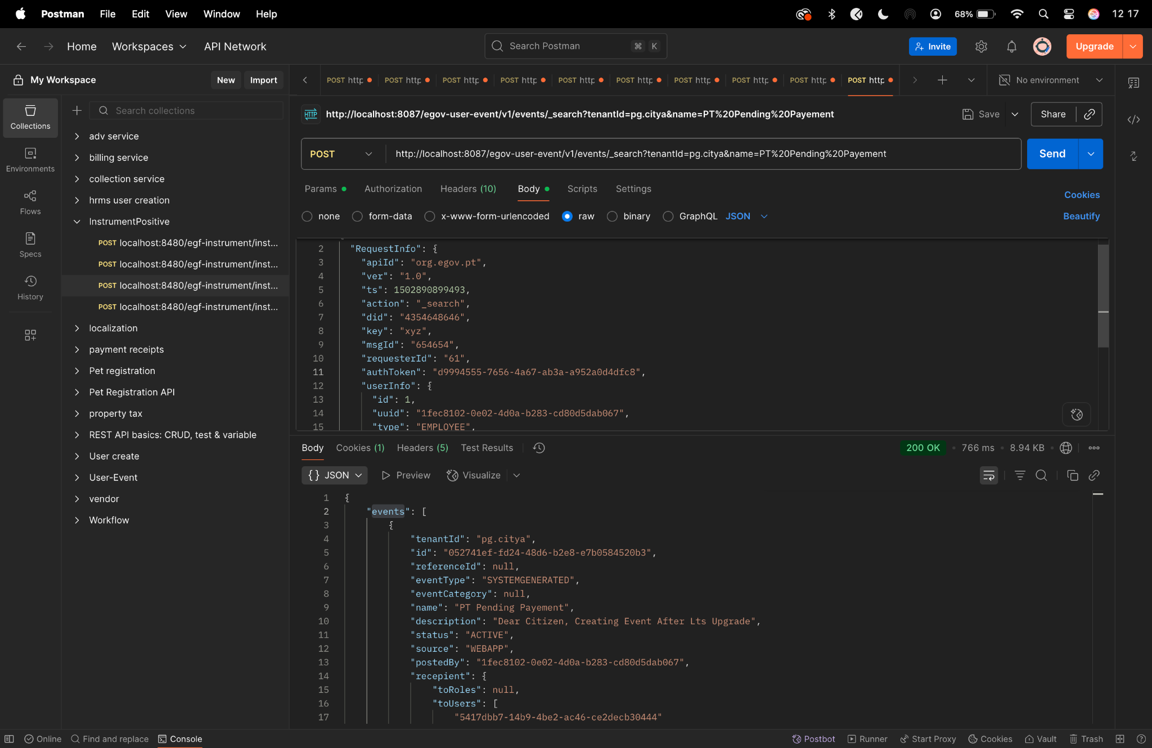

Diff checker-

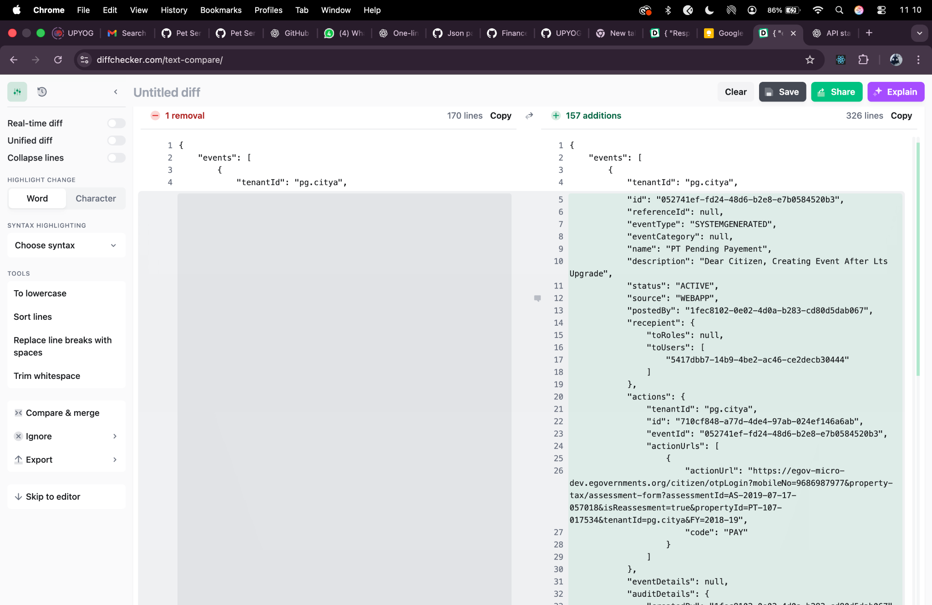

**Count Curl-**

curl --location 'http://localhost:8087/egov-user-event/v1/events/notifications/_count?tenantId=pg.citya' \

--header 'Content-Type: application/json' \

--header 'Cookie: JSESSIONID=64B00DE3C5A51A09ACAF5A7142EFECDE' \

--data '{

"RequestInfo": {

"apiId": "org.egov.pt",

"ver": "1.0",

"ts": 1502890899493,

"action": "asd",

"did": "4354648646",

"key": "xyz",

"msgId": "654654",

"requesterId": "61",

"authToken": "0590b6f3-4906-4d24-a862-ec06070203b1",

"userInfo": {

"id": 1,

"uuid":"5417dbb7-14b9-4be2-ac46-ce2decb30444",

"type": "CITIZEN",

"tenantId": "pg.citya",

"roles": [

{

"name": "Citizen",

"code": "CITIZEN",

"tenantId": "pg.citya"

}

]

}

}

}'

**Response-**

{

"totalCount": 10,

"unreadCount": 3,

"ResponseInfo": {

"apiId": "org.egov.pt",

"ver": "1.0",

"ts": 1502890899493,

"resMsgId": "uief87324",

"msgId": "654654",

"status": "successful"

}

}

Postman-

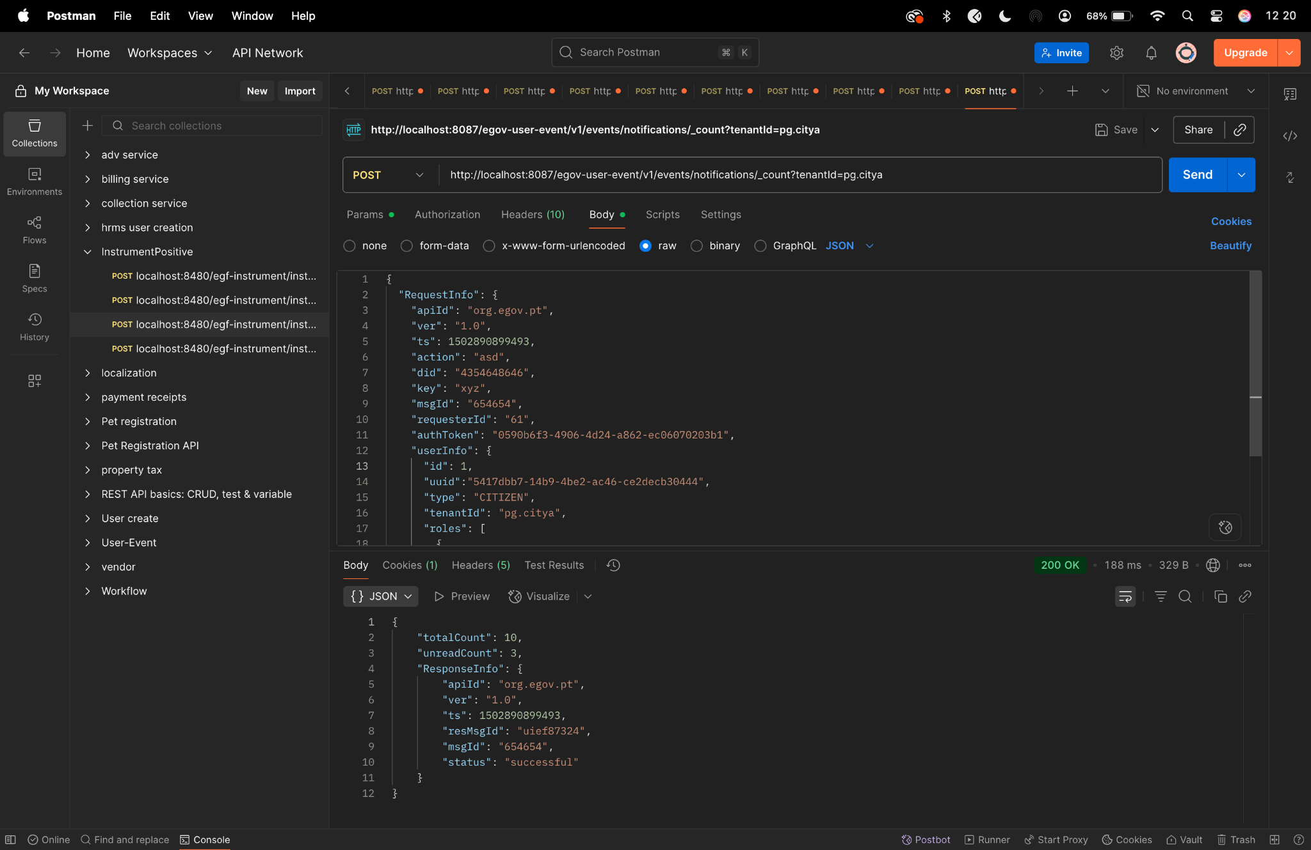

Diff checker-

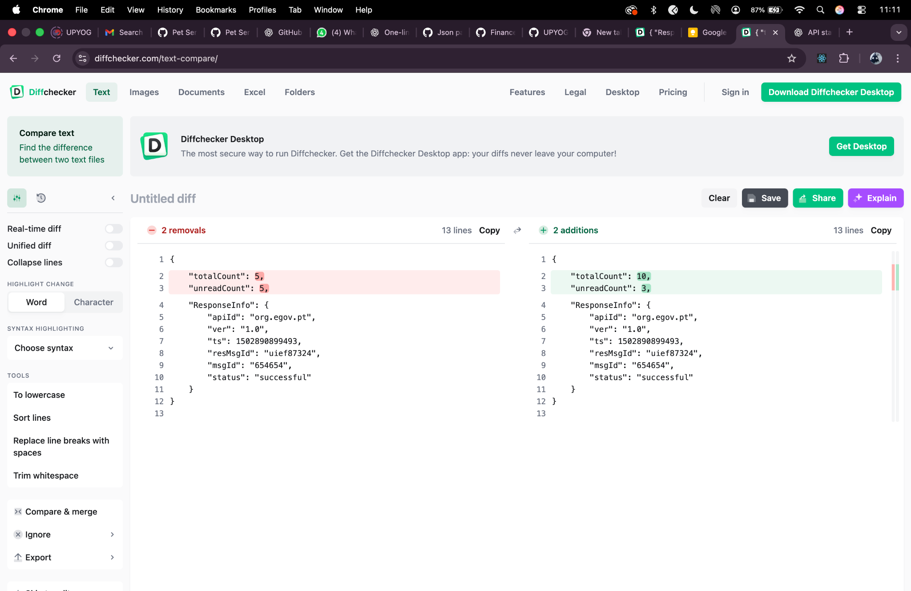

**LAT (Last Access Time) - update Curl**

* Before /lat/_update: Notifications created before the user's last access time were "unread"
* After /lat/_update: The user's last access time was updated to current timestamp
* Now all existing notifications are considered "read" since they were created before the updated last access time

**lat/_update Curl -**

curl --location 'http://localhost:8087/egov-user-event/v1/events/lat/_update' \

--header 'Content-Type: application/json' \

--header 'Cookie: JSESSIONID=64B00DE3C5A51A09ACAF5A7142EFECDE' \

--data '{

"RequestInfo": {

"apiId": "org.egov.pt",

"ver": "1.0",

"ts": 1502890899493,

"action": "asd",

"did": "4354648646",

"key": "xyz",

"msgId": "654654",

"requesterId": "61",

"authToken": "685176f7-45dd-40b3-8821-93912a6d3dc0",

"userInfo": {

"id": 1,

"uuid":"5417dbb7-14b9-4be2-ac46-ce2decb30444",

"type": "CITIZEN",

"tenantId": "pg.citya",

"roles": [

{

"name": "Citizen",

"code": "CITIZEN",

"tenantId": "pg.citya"

}

]

}

}

}'

**Response -**

{

"apiId": "org.egov.pt",

"ver": "1.0",

"ts": 1502890899493,

"resMsgId": "uief87324",

"msgId": "654654",

"status": "successful"

}

Postman-

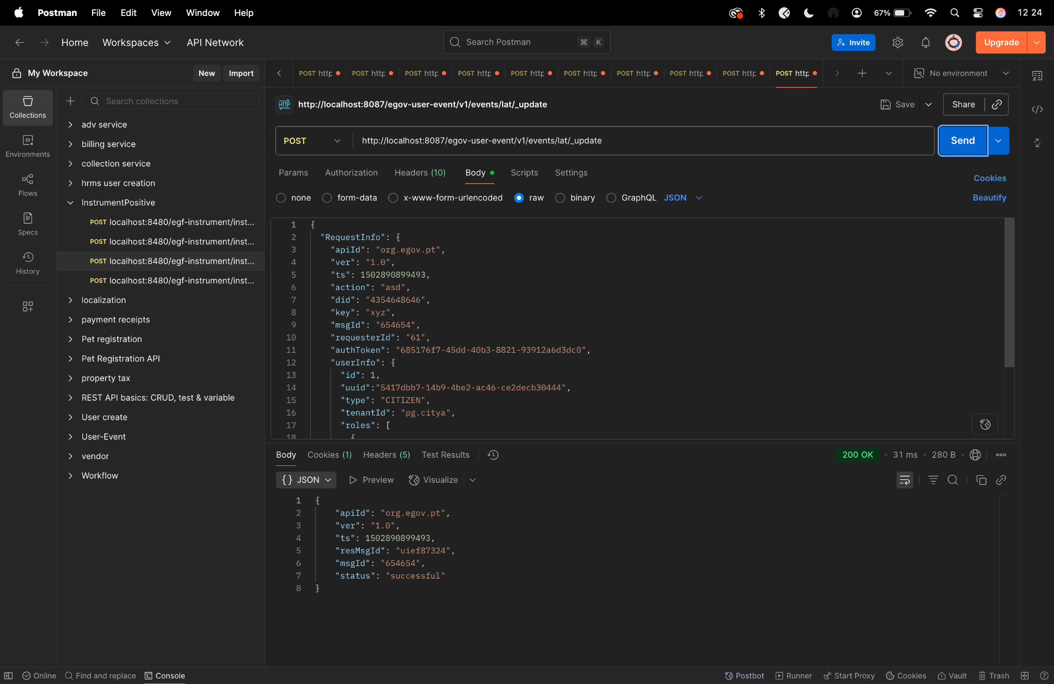

Diff checker-

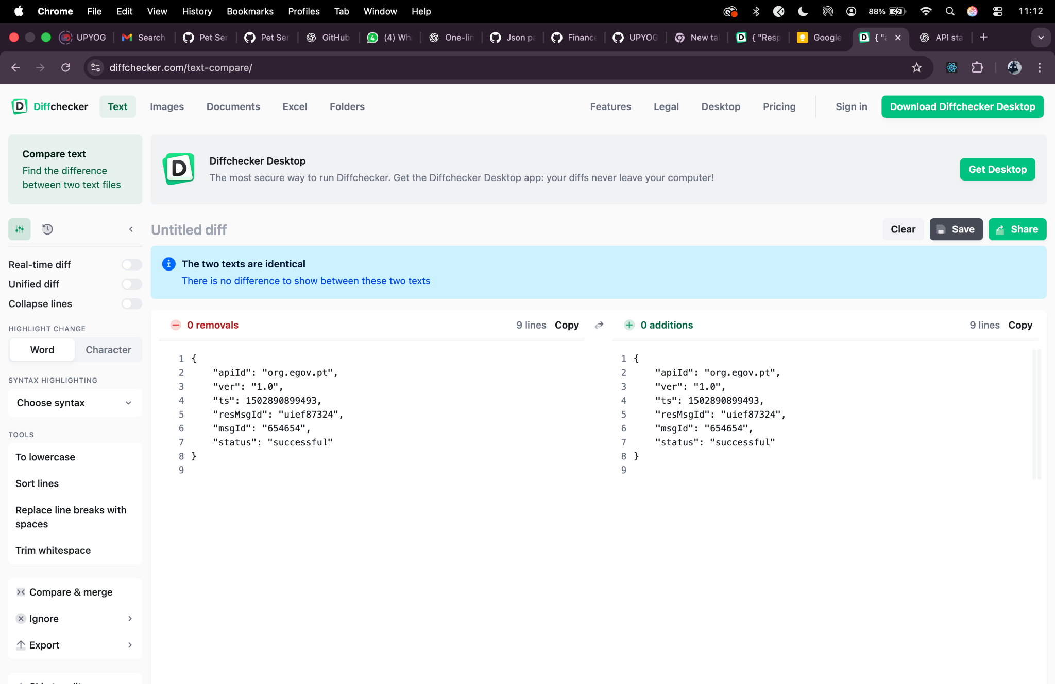

**Update curl -**

curl --location 'http://localhost:8087/egov-user-event/v1/events/_update' \

--header 'Content-Type: application/json' \

--header 'Cookie: JSESSIONID=64B00DE3C5A51A09ACAF5A7142EFECDE' \

--data '{

"RequestInfo": {

"apiId": "org.egov.pt",

"ver": "1.0",

"ts": 1502890899493,

"action": "asd",

"did": "4354648646",

"key": "xyz",

"msgId": "654654",

"requesterId": "61",

"authToken": "d1ddc056-d5bb-4c65-ad49-c3c04595fc31",

"userInfo": {

"id": 1,

"uuid": "052741ef-fd24-48d6-b2e8-e7b0584520b3",

"type": "EMPLOYEE",

"tenantId": "pg.citya",

"roles": [

{

"name": "Employee",

"code": "EMPLOYEE",

"tenantId": "pg.citya"

}

]

}

},

"events": [

{

"tenantId": "pg.citya",

"id": "335b84c0-5288-4476-8b9b-618ae411c322",

"eventType": "EVENTSONGROUND",

"eventCategory": "PUBLICHEALTH",

"name": "PT Pending Payement",

"description": "Dear Citizen, Creating Event After Lts Upgrade- UPDATED DESCRIPTION after Update curl-------------",

"status": "ACTIVE",

"source": "WEBAPP",

"eventDetails": {

"organizer": "Soorya P - Updated",

"fromDate": 1767225600000,

"toDate": 1767312000000,

"latitude": 11.11,

"longitude": 11.11,

"address": "Updated Address - Mcleod Road, Rani Ka Bagh, Amritsar",

"fees": 1500

},

"auditDetails": {

"createdBy": "1fec8102-0e02-4d0a-b283-cd80d5dab067",

"createdTime": 1565079560614,

"lastModifiedBy": "1fec8102-0e02-4d0a-b283-cd80d5dab067",

"lastModifiedTime": 1757333919582

}

}

]

}'

**Response -**

{

"events": [

{

"tenantId": "pg.citya",

"id": "335b84c0-5288-4476-8b9b-618ae411c322",

"referenceId": null,

"eventType": "EVENTSONGROUND",

"eventCategory": "PUBLICHEALTH",

"name": "PT Pending Payement",

"description": "Dear Citizen, Creating Event After Lts Upgrade- UPDATED DESCRIPTION after Update curl-------------",

"status": "ACTIVE",

"source": "WEBAPP",

"postedBy": null,

"recepient": null,

"actions": null,

"eventDetails": {

"id": "78e74b9d-362c-49e2-b8fd-3e5039d235ae",

"eventId": "03004109-e7b3-4d78-afb3-45619ea4bf88",

"organizer": "Soorya P - Updated",

"fromDate": 1767225600000,

"toDate": 1767312000000,

"latitude": 11.11,

"longitude": 11.11,

"address": "Updated Address - Mcleod Road, Rani Ka Bagh, Amritsar",

"documents": null,

"fees": 1500

},

"auditDetails": {

"createdBy": "1fec8102-0e02-4d0a-b283-cd80d5dab067",

"createdTime": 1565079560614,

"lastModifiedBy": "052741ef-fd24-48d6-b2e8-e7b0584520b3",

"lastModifiedTime": 1757487644561

},

"recepientEventMap": null,

"generateCounterEvent": null,

"internallyUpdted": null

}

],

"ResponseInfo": {

"apiId": "org.egov.pt",

"ver": "1.0",

"ts": 1502890899493,

"resMsgId": "uief87324",

"msgId": "654654",

"status": "successful"

}

}

Postman-

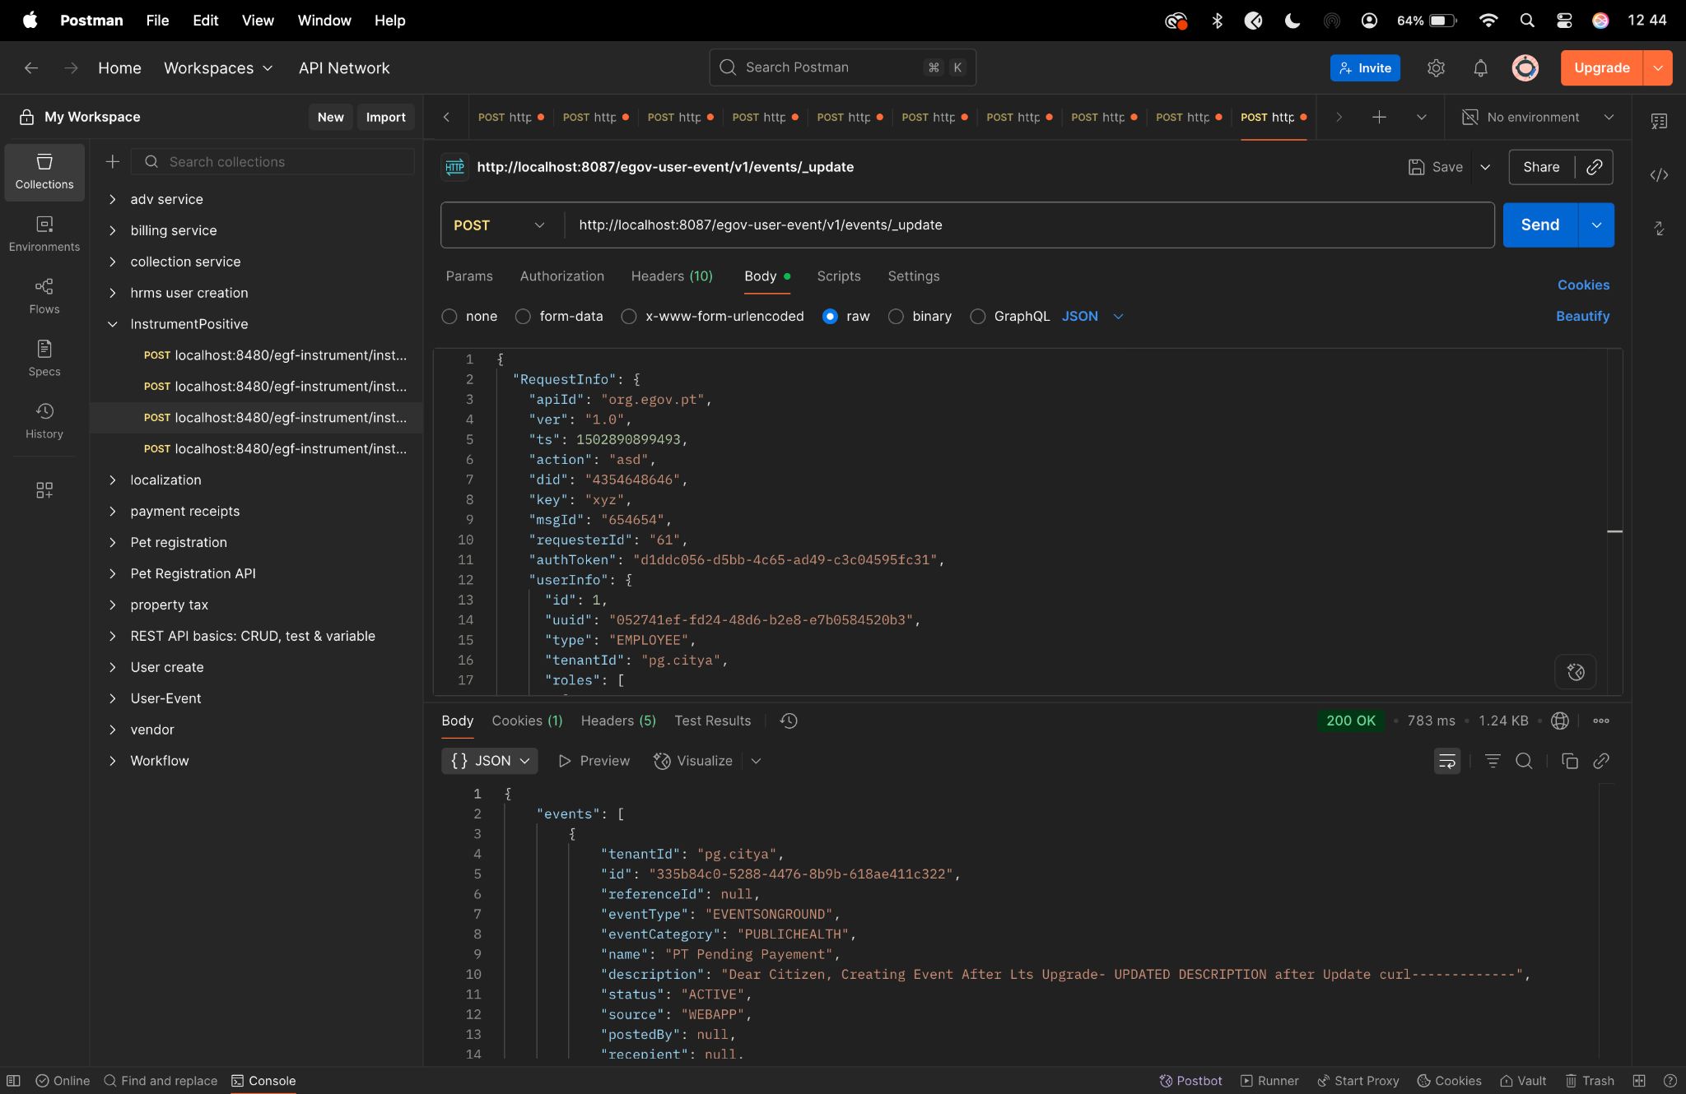

Diff checker-

